NEARBY PLACE

This tutorial describes the usage of the Google Map API.

**EXAMPLE : Get Nearby Place Google Map Api**

Before starting get near by places, First we need to **enable** the **Place API**.

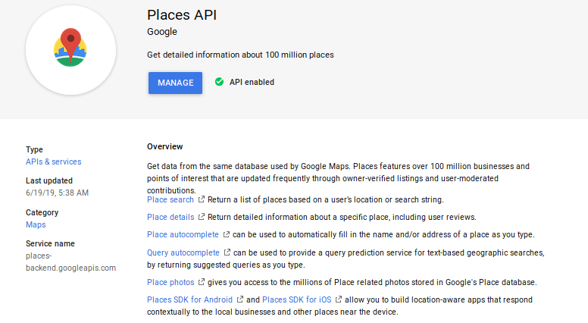

Nearby Search and Text Search return all of the available data fields for the selected place (a [subset of the supported fields](https://developers.google.com/places/web-service/place-data-fields" \l "places-api-fields-support)), and you will be [billed accordingly](https://developers.google.com/maps/billing/understanding-cost-of-use" \l "nearby-search) There is no way to constrain Nearby Search or Text Search to only return specific fields. To keep from requesting (and paying for) data that you don't need, use a [Find Place request](https://developers.google.com/places/web-service/search" \l "FindPlaceRequests) instead.

A Nearby Search lets you search for places within a specified area. You can refine your search request by supplying keywords or specifying the type of place you are searching for.

A Nearby Search request is an HTTP URL of the following form :

<https://maps.googleapis.com/maps/api/place/nearbysearch/output?parameters>

***where output may be either of the following values :***

* **json** (recommended) indicates output in JavaScript Object Notation (JSON)
* **xml** indicates output as XML

Certain parameters are required to initiate a Nearby Search request. As is standard in URLs, all parameters are separated using the ampersand (&) character.

***Required parameters***

* **key —** Your application's **[API key](https://cloud.google.com/docs/authentication/api-keys)**. This key identifies your application. See **[Get a key](https://developers.google.com/places/web-service/get-api-key)** for more information.
* **location —** The latitude/longitude around which to retrieve place information. This must be specified as latitude,longitude.
* **radius —** Defines the distance (in meters) within which to return place results. The maximum allowed radius is 50 000 meters. Note that radius must not be included if **rankby=distance** (described under Optional parameters below) is specified.
* If **rankby=distance** (described under Optional parameters below) is specified, then one or more of keyword, name, or type is required.

***Optional parameters***

* **keyword —** A term to be matched against all content that Google has indexed for this place, including but not limited to name, type, and address, as well as customer reviews and other third-party content.
* **language —** The language code, indicating in which language the results should be returned, if possible. See the [list of supported languages](https://developers.google.com/maps/faq" \l "languagesupport) and their codes. Note that we often update supported languages so this list may not be exhaustive.
* **minprice and maxprice (optional) —** Restricts results to only those places within the specified range. Valid values range between 0 (most affordable) to 4 (most expensive), inclusive. The exact amount indicated by a specific value will vary from region to region.
* **name —** A term to be matched against all content that Google has indexed for this place. Equivalent to keyword. The name field is no longer restricted to place names. Values in this field are combined with values in the keyword field and passed as part of the same search string. We recommend using only the keyword parameter for all search terms.
* **opennow —** Returns only those places that are open for business at the time the query is sent. Places that do not specify opening hours in the Google Places database will not be returned if you include this parameter in your query.
* **rankby —** Specifies the order in which results are listed. Note that rankby must not be included if radius (described under Required parameters above) is specified. Possible values are :
* **prominence (default)**. This option sorts results based on their importance. Ranking will favor prominent places within the specified area. Prominence can be affected by a place's ranking in Google's index, global popularity, and other factors.
* **distance**. This option biases search results in ascending order by their distance from the specified location. When distance is specified, one or more of keyword, name, or type is required.
* **type —** Restricts the results to places matching the specified type. Only one type may be specified (if more than one type is provided, all types following the first entry are ignored). See the [list of supported types](https://developers.google.com/places/web-service/supported_types).
* **pagetoken —** Returns the next 20 results from a previously run search. Setting a pagetoken parameter will execute a search with the same parameters used previously — all parameters other than pagetoken will be ignored.

***Note for Google Maps APIs Premium Plan customers :*** *You must include an API key in your requests. You should not include a client or signature parameter with your requests.*

***Nearby search example***

*The following example is a search request for places of type 'restaurant' within a 1500m radius of a point in Sydney, Australia, containing the word 'cruise' :*

<https://maps.googleapis.com/maps/api/place/nearbysearch/json?location=-33.8670522,151.1957362&radius=1500&type=restaurant&keyword=cruise&key=YOUR_API_KEY>

***Note :*** *In this example, you need to replace the key with your own API key in order for the request to work in your application.*

One workaround is to pass the value in the parameter name inside double quotes such as:

Call call = apiService.doPlaces(placeType, latLngString,"\""+ businessName +"\"", true, "distance", APIClient.GOOGLE_PLACE_API_KEY);

The output comes up like this for my location is given below:

[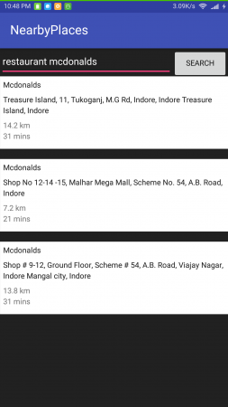](https://cdn.journaldev.com/wp-content/uploads/2017/03/android-nearbyplaces-output-2.png)

<https://stackoverflow.com/questions/30161395/im-trying-to-search-nearby-places-such-as-banks-restaurants-atms-inside-the-d>

<https://github.com/AkshayRaj/GooglePlacesAndroid>

<https://github.com/mitchtabian/Google-Maps-Google-Places>

<https://github.com/Esri/nearby-android>